Report on the work done
Of the Consultant of charitable foundation “Social Equation Hub”
Ketevan Kobiashvili
Date | Activities implemented | Result | Time
10.06.2025  20.06.2026 | Preparation of the regional meeting (SoS 2025) | A concept and agenda for the upcoming regional meeting were developed, with key topics aligned to project objectives. Preparatory communication with participants and partners was initiated to ensure timely engagement.  Application 1: Regional meeting preparation | 16 hour
10.06.2025; 14.06.2025; 17.06.2025 | Coordination with local consultant to support project objectives and monitor the progress in Moldova | Regular communication was maintained with the national consultant to support the implementation of planned activities. Progress on integrating mental health into HIV services was monitored and technical guidance was provided where needed.  Application 2: Integration of mental health services in Moldova  Application 3: Developing and adapting policy recommendations for ensuring health service continuity in Moldova | 5 hour
11.06.2025;18.06.2025 | Coordination with local consultant to support project objectives and monitor the progress in Tajikistan | Close coordination ensured alignment with national planning timelines and consultant deliverables. Key inputs were provided to support budget development and the integration of mental health components into national programs.  Application 4: meeting protocols | 3 hour
23.06.2025; 24.06.2025; 25.06.2025; | Coordination and organisation of documents, preparation of the quarter report | All relevant documents and updates were collected, reviewed, and organized into a structured format. A draft version of the quarterly report was prepared, incorporating inputs from country teams and consultants.  Application 5: Quarter report draft | 28 hour
19.06.2025;  20.06.2025 26.06.2025 | Preparation of meeting protocols, technical organization of the meetings and working plan | Meeting discussions were documented in a structured format, with clear action points and follow-up responsibilities. Application 6: Calendar and meeting protocols  consultation register: https://docs.google.com/spreadsheets/d/1pvX34kK2_-gcN_CvqvuleEuB6jrjzwAi6EAMfoCXhiA/edit?gid=0#gid=0 | 20 hour
3.06.2025;  4.06.2025;  5.06.2025;  6.06.2025 | Translation of strategic documents | Strategic documents, including technical guidance and planning frameworks, were translated to ensure accessibility for country-level implementation.  Application 7: translation of the strategic documents | 28 hour

Period of service provision: 01.06.2025 - 26.06.2025
Total number of days: 12.5

Annexes:
Application 1: Regional meeting preparation
Application 2: Integration of mental health services in Moldova
Application 3: Developing and adapting policy recommendations for ensuring health service continuity in Moldova
Application 4: meeting protocols
Application 5: Quarter report draft
Application 6: Calendar and meeting protocols; consultation register: https://docs.google.com/spreadsheets/d/1pvX34kK2_-gcN_CvqvuleEuB6jrjzwAi6EAMfoCXhiA/edit?gid=0#gid=0
Application 7: translation of the strategic documents

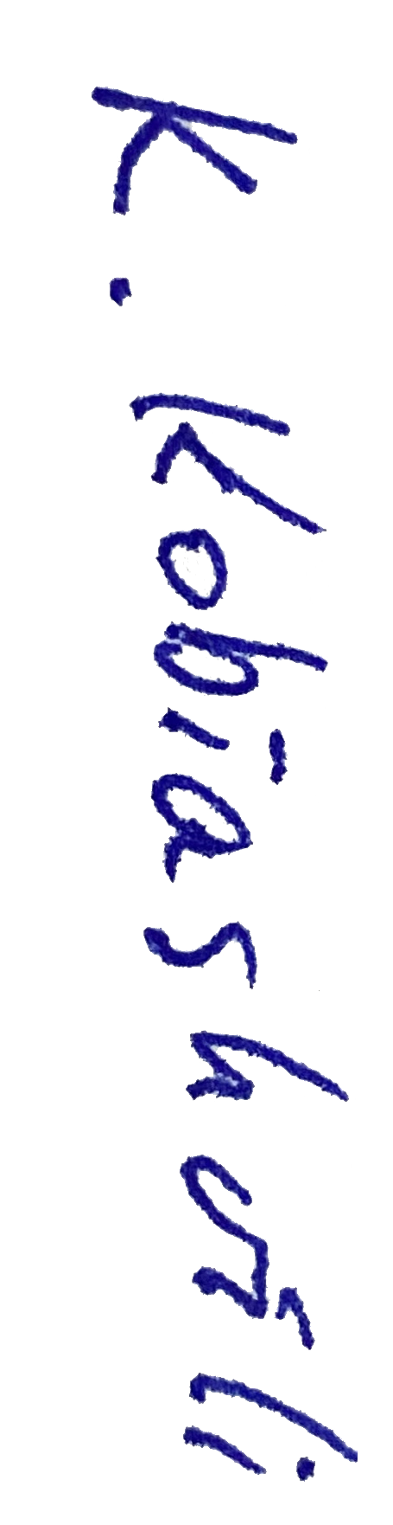
Date Signature Name, Last Name
26.06.2025 Ketevan Kobiashvili

